**Shri Ramdeobaba College of Engineering and Management, Nagpur**

**Department of Computer Science and Engineering**

**Session: 2025-26**

**Design and Analysis of Algorithms Lab III Semester**

**PRACTICAL NO. 5**

**Aim:** Implement Longest Common Subsequence (LCS) algorithm to find the length and LCS for DNA sequences.

**Problem Statement:**

DNA sequences can be viewed as strings of A, C, G, and T characters, which represent nucleotides. Finding the similarities between two DNA sequences are an important computation performed in bioinformatics.

[Note that a subsequence might not include consecutive elements of the original sequence.]

**TASK-1:** Find the similarity between the given X and Y sequence.

X=AGCCCTAAGGGCTACCTAGCTT

Y= GACAGCCTACAAGCGTTAGCTTG

**Output:** Cost matrix with all costs and direction, final cost of LCS and the LCS.

LCS is:

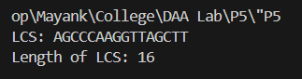

**TASK-2:** Find the longest repeating subsequence (LRS). Consider it as a variation of the longest common subsequence (LCS) problem.

Let the given string be S. You need to find the LRS within S. To use the LCS framework, you effectively compare S with itself. So, consider string1 = S and string2 = S.

Example:

**AABCBDC**

**LRS=** ABC or ABD

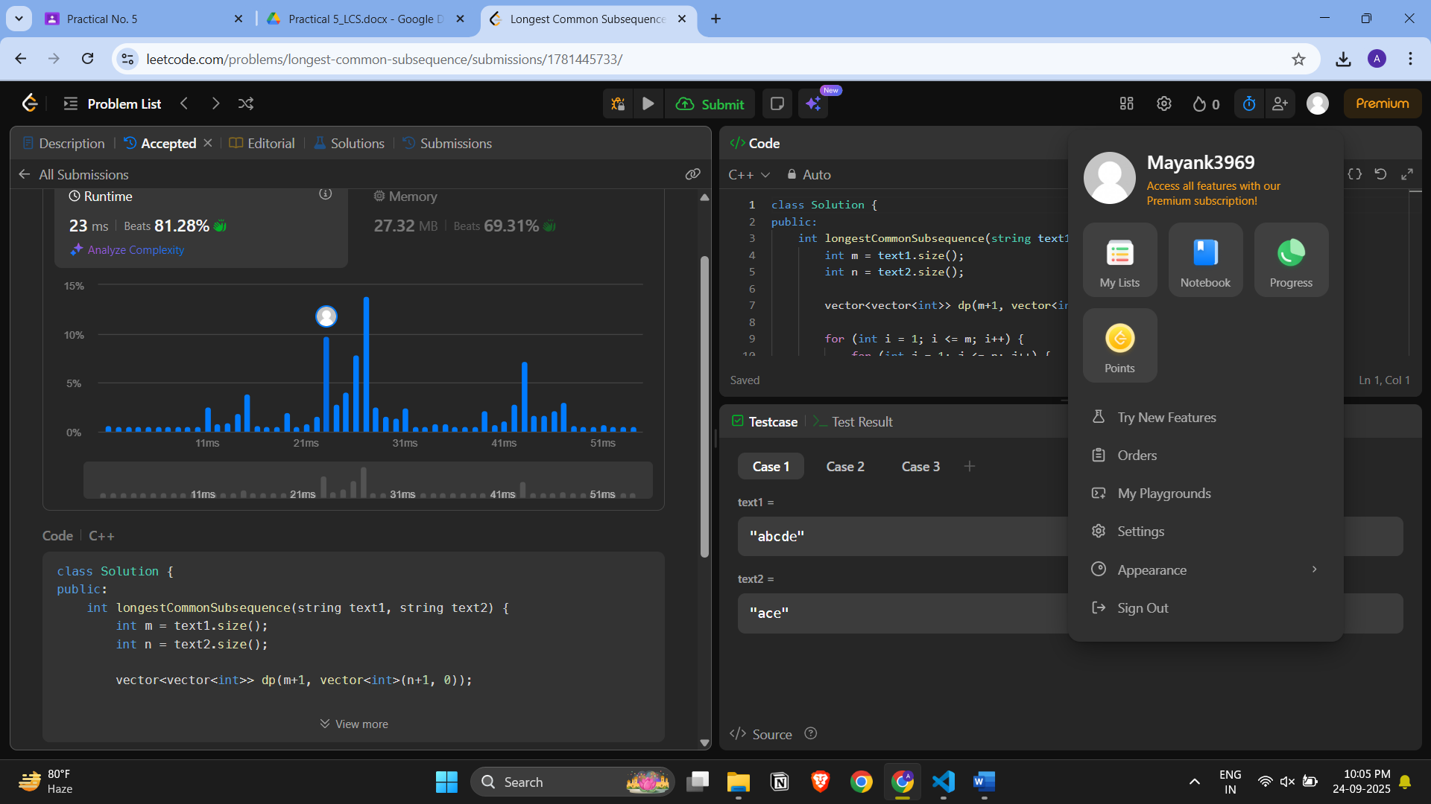

**LeetCode Assesment:**

<https://leetcode.com/problems/longest-common-subsequence/description/>

**Practical 5 submission:**

* Submit as usual on GC
* Also, create repository on your Github account and submit the public repo link with the code uploaded on it. Add this link in the GC document as well.

**Github Repo-** https://github.com/Mayank3969/DAA-LAB-P5